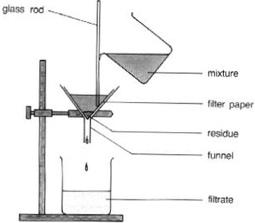

Year 7 – Filtration Question

How would you separate a solid mixture of sodium chloride and saw dust so as to get each one on their own?

1. Add water so as to dissolve the salt only

2. Filter the mixture so as to have the saw dust as the residue and the salt in the filtrate.

3. Dry the filter paper so as to remove the moisture (water)

4. Evaporate the water out of the filtrate so as to crystallise the salt.